**User Case (Not complete yet)**

1. **Layout**
   1. **Refer to the website below**

[**https://www.mcmaster.com/**](https://www.mcmaster.com/)

* 1. **Search bar on the top**
  2. **Logo (TBD) on the top left**
  3. **Contact Us, BOM, Log In on the top right**
  4. **Choose a Category on the left**
  5. **All Categories takes the main page**

1. **Search**

<https://www.mcmaster.com/>

<https://www.mcmaster.com/power-supplies>

<https://www.mcmaster.com/power-supplies/din-rail-power-supplies-6/>

<https://www.mcmaster.com/power-supplies/din-rail-power-supplies-6/output-voltage~24v-dc/>

(Note: These links are used below. I like the way they organize the above links: main page -> category -> sub category -> part -> filtered part)

* 1. When typing, show results without enter. See Fig. 1.

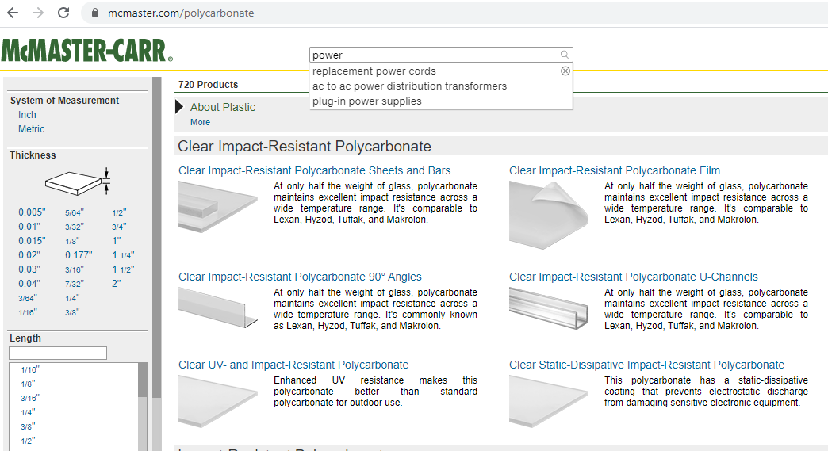

Fig. 1-1

* 1. Writing prompts; see Fig. 1-1
  2. Show the highest category if key words are not specific enough; see Fig. 1-2

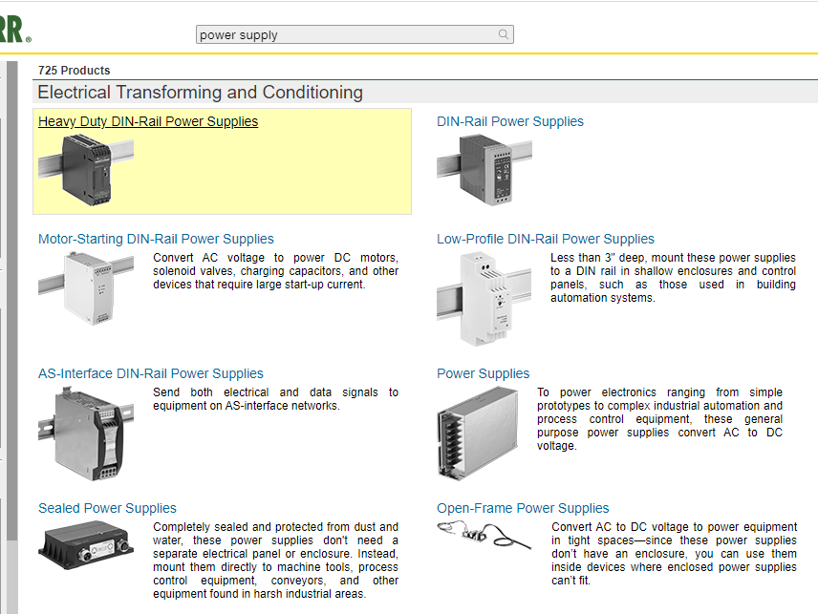

Fig. 1-2

* 1. If search part number, it goes directly to that part and the ADD TO BOM button/page; see Fig. 1-3. (note: I noticed that when type in specific part numbers, the filter bar on the left disappears).

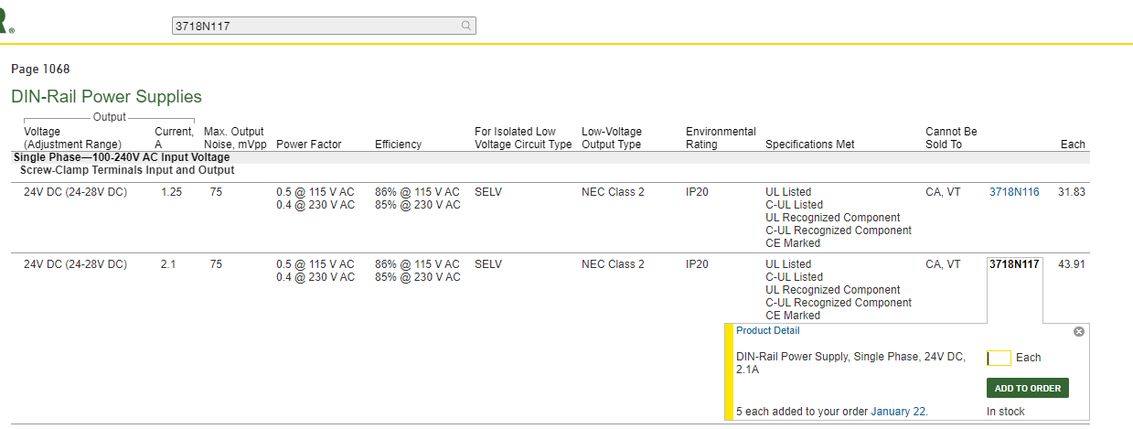

Fig. 1-3

1. **Filter**

<https://www.mcmaster.com/power-supplies/din-rail-power-supplies-6/>

* 1. Clear all; see Fig 2-1

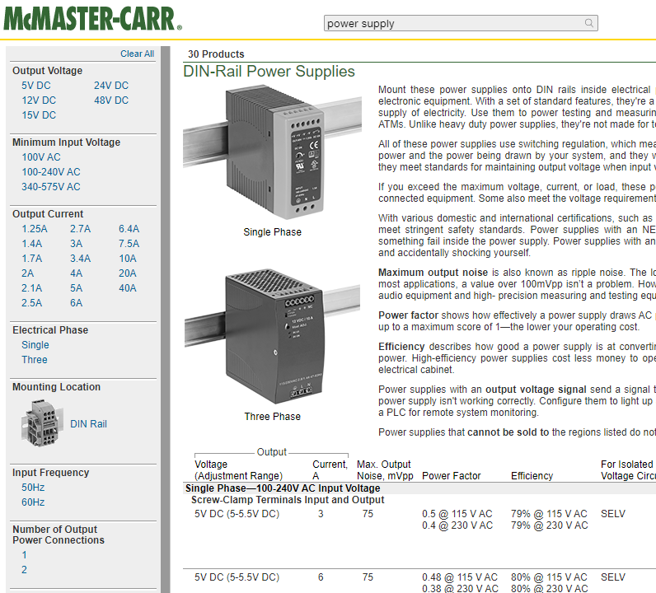

Fig. 2-1

* 1. Multiple filters; see Fig. 2-1
  2. Under each filter, there are multiple options or specifications; see Fig. 2-1
  3. May have images; see Fig. 2-1
  4. Show button can show the hidden options; see Fig. 2-2

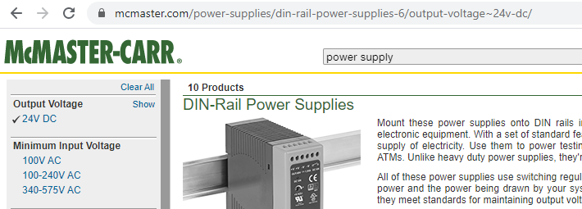

Fig. 2-2

* 1. If there are many options under a filter, then show options in the format of list (sliding bar) and with mini search bar on top of each sliding bar; see Fig. 2-3

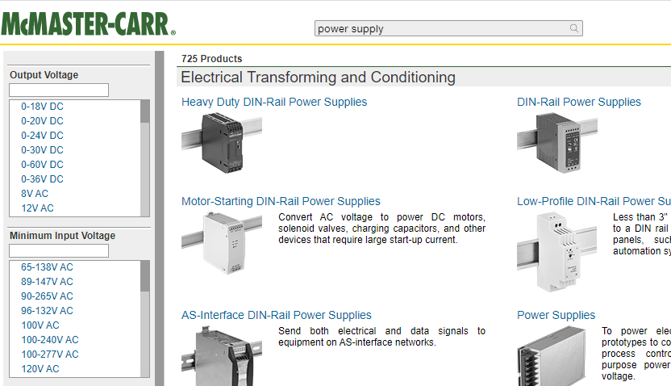

Fig. 2-3

1. Show more button shows more filters; see Fig. 2-4

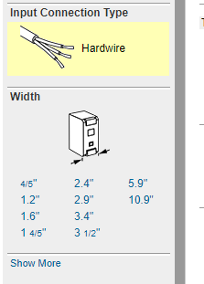

Fig. 2-4

1. **Select parts and add to BOM**

<https://www.mcmaster.com/power-supplies/din-rail-power-supplies-6/output-voltage~24v-dc/>

* 1. Click part number (or the row the part belongs), show a window to set qty; see Fig. 3-1

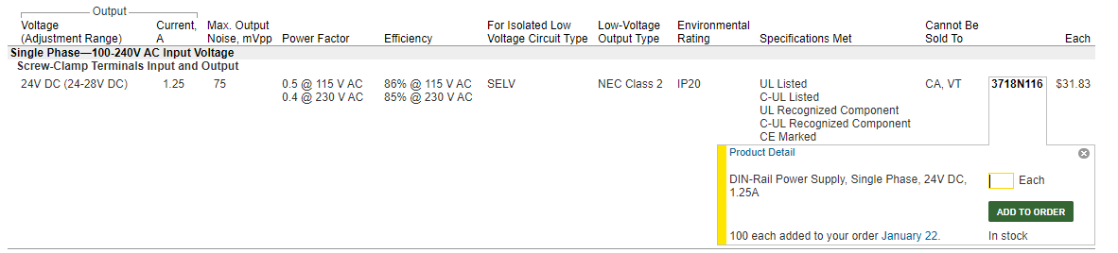

Fig. 3-1.

* 1. Click add to BOM Button (Change ADD TO ORDER to ADD TO BOM), see Fig. 3-1
  2. Show message to confirm the parts have been added; see Fig. 3-2 (message: qty. 10 added to your BOM.

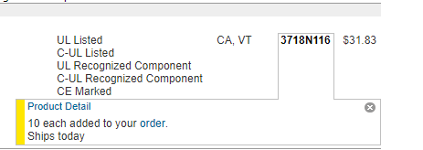

Fig. 3-2

* 1. All product info is shown on only one page; see link below.

<https://www.mcmaster.com/power-supplies/din-rail-power-supplies-6/output-voltage~24v-dc/>

1. **BOM button**
   1. Click BOM button to show the BOM (Change ORDER to BOM); see Fig. 4-1

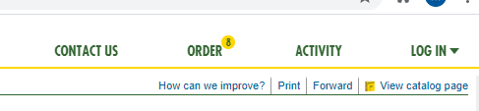

Fig. 4-1

* 1. BOM will look like this; see Fig. 4-2; no photo is needed on BOM.

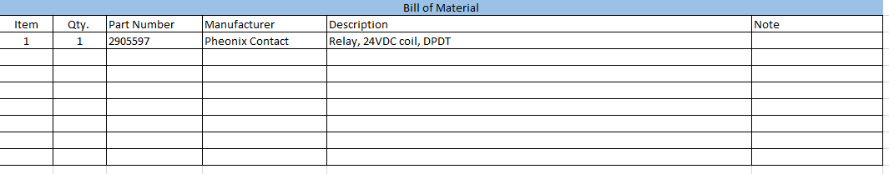

Fig. 4-2

* 1. BOM shows items are duplicated if they are; see Fig. 4-3

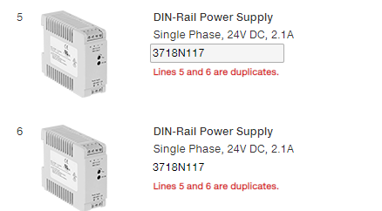

Fig. 4-3

* 1. Add a line button is used to directly add a part if part number is known; Change “Add a line” to “Add a part”; see Fig. 4-4

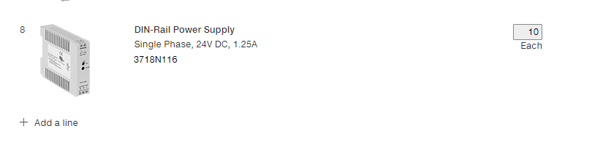

Fig. 4-4

* 1. Top left corner, Project number can be added; see Fig. 4-5
     1. Change Order to BOM
     2. Change “Purchase Order (Optional)” to “Project Number (Optional)”

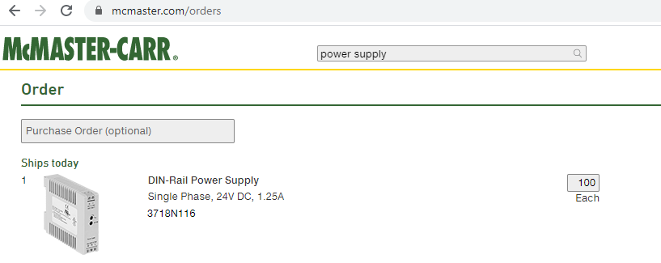

Fig. 4-5

* 1. Save for later button
     1. Change Save your order as to “Save your BOM as”
        1. In the box, add (Project Number, Description, etc.)
     2. Change “Logging in is required to view saved orders” to “Logging in is required to view saved BOM”.

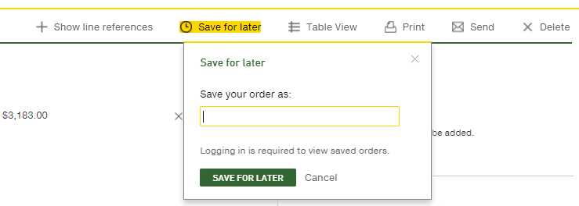

Fig. 4-6

**Not complete yet. You can Ignore everything from below for now.**